6. Testing and Validation Artefacts (Industry-Level Detail)
Comprehensive testing and validation are essential for demonstrating reliability, safety, and performance in a regulated medical AI system. All tests use only public or fully anonymised datasets (no real patient data), aligning with UK GDPR, MHRA GMLP, and NHS digital standards. Artefacts are placed in /tests/ and /docs/validation/ for assessor review, with commit history showing iterative improvements.
Key Components
- Testing Framework: pytest with coverage (pytest-cov) – unit tests for individual modules (anonymisation, ViT inference, LLM drafting), integration tests for pipeline end-to-end.
- Datasets Used:
  - Chest X-rays: MIMIC-CXR-JPG (PhysioNet), PadChest, NIH ChestX-ray14.
  - General/Other: TCIA collections (e.g., LIDC-IDRI for lung nodules).
  - Reports: IU X-ray or MIMIC-CXR paired reports for ground truth.
- Metrics:
  - ViT Analysis: Accuracy, Sensitivity, Specificity, AUC-ROC (per-class and macro-averaged).
  - Report Drafting: BLEU-4, ROUGE-L, METEOR (compared to reference reports).
- Pilot Simulations: Timed runs on sample cases (manual transcription vs AI-assisted editing) using public images.
- Error Handling: Structured logging (Python logging module) capturing invalid inputs, model failures, timeouts.
Industry-Level Example Diagrams and Visuals
Figure 43: Sample pytest unit and integration test results with coverage report (Standard output showing passed/failed tests.)
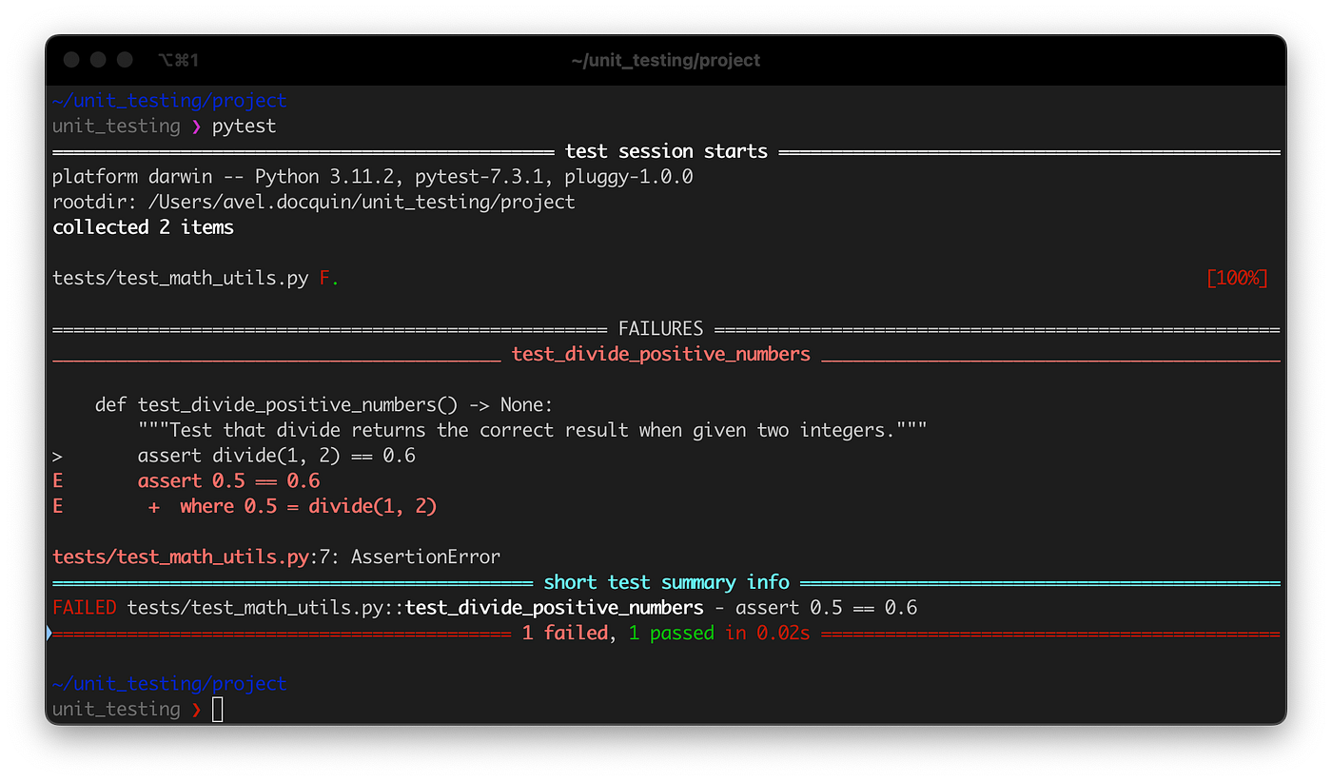
medium.com
Python Unit Tests with pytest Guide | Avel Docquin | Medium
Suggested filename: fig43-pytest-results-example.pdf
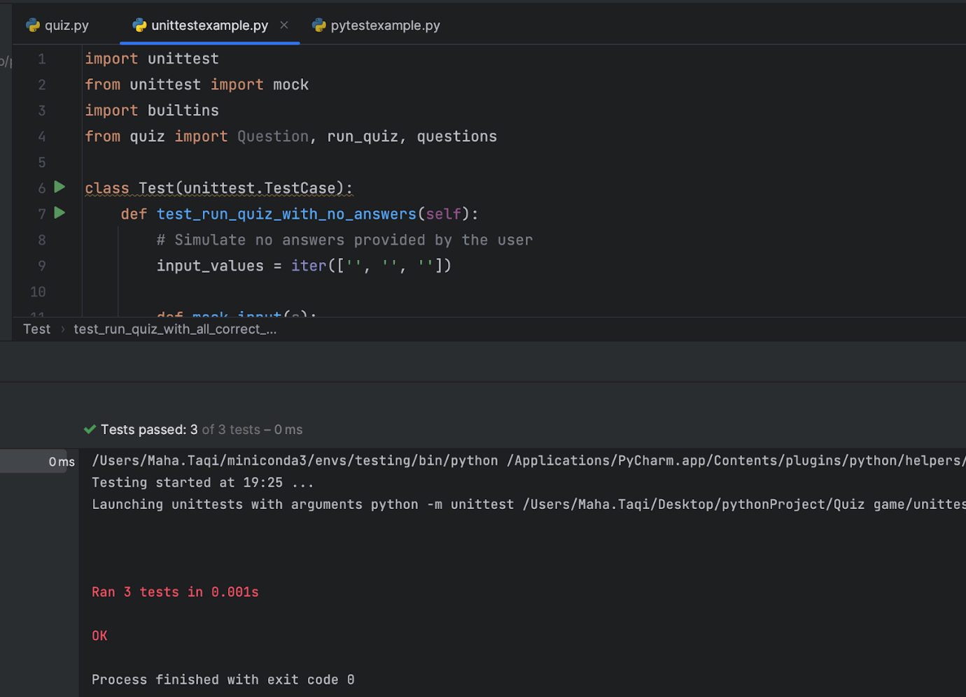
blog.jetbrains.com
Pytest vs. Unittest: Which Is Better? | The PyCharm Blog
Suggested filename: fig44-pytest-verbose-output.pdf
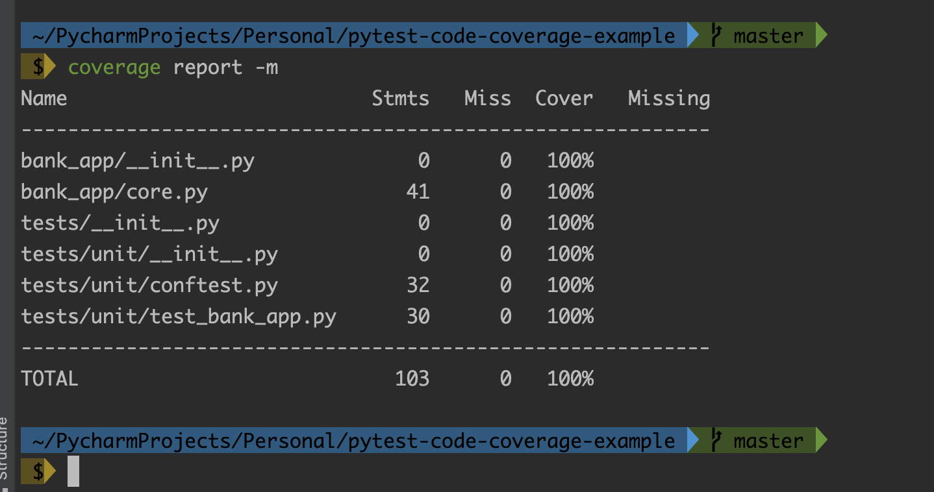
pytest-with-eric.com
How To Generate Beautiful & Comprehensive Pytest Code Coverage ...
Suggested filename: fig45-pytest-coverage-report.pdf
Figure 46: Sample chest X-ray images from MIMIC-CXR dataset used for validation (Public anonymised examples for testing.)
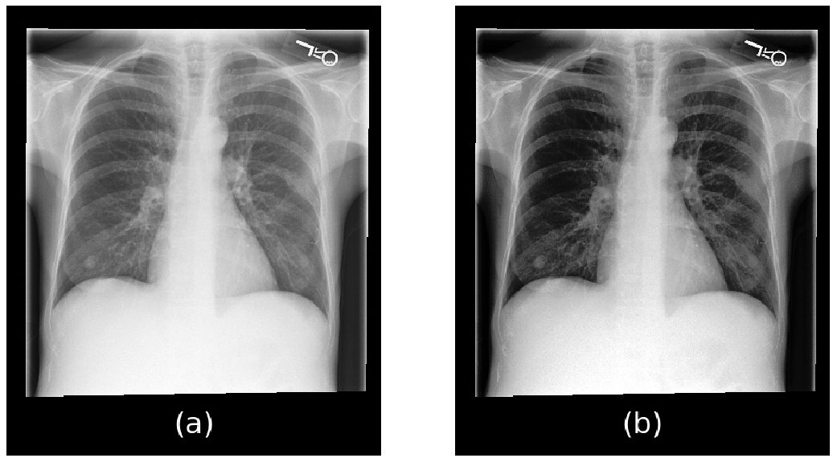
semanticscholar.org
PDF] MIMIC-CXR-JPG, a large publicly available database of labeled ...
Suggested filename: fig46-mimic-cxr-samples.pdf
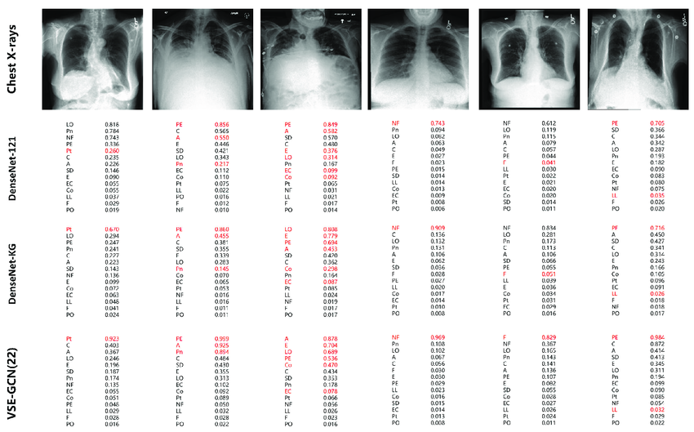
researchgate.net
Diagnostic results of six samples from MIMIC-CXR test set. Three ...
Suggested filename: fig47-mimic-cxr-diagnostic-samples.pdf
Figure 48: ROC curves with AUC values for Vision Transformer models in medical imaging (Performance metrics for classification tasks.)
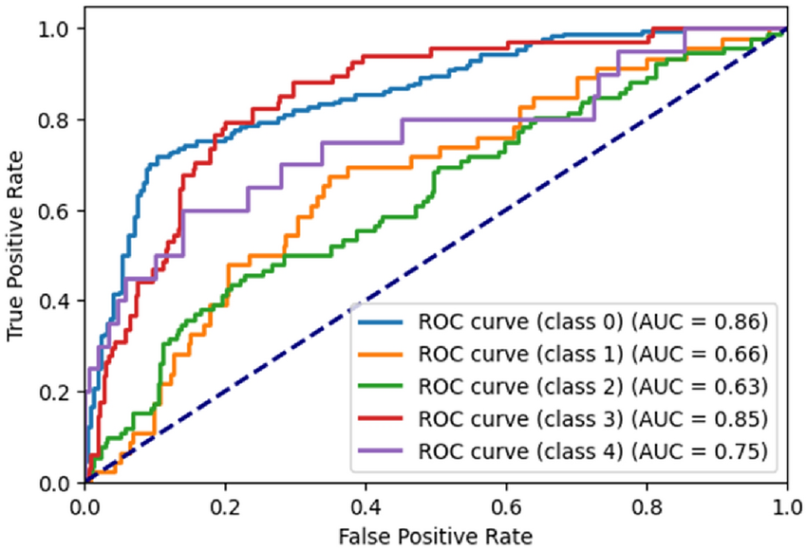
researchgate.net
ROC curve generated by the proposed ViT model for RetinaMNIST ...
Suggested filename: fig48-vit-roc-curve.pdf
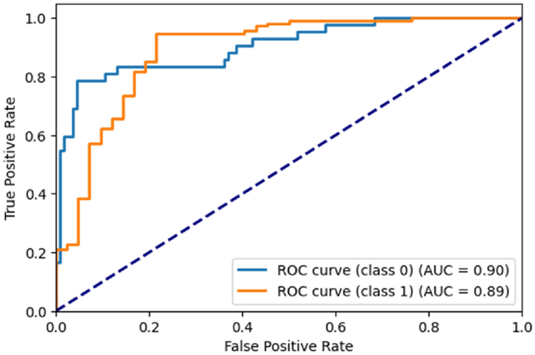
nature.com
Implementing vision transformer for classifying 2D biomedical ...
Suggested filename: fig49-vit-biomedical-roc.pdf
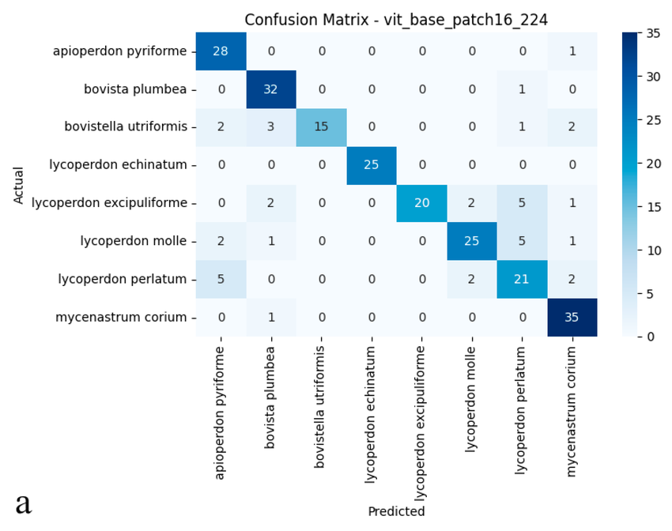
researchgate.net
a) Confusion matrix and (b) ROC curves with AUC values of the ...
Suggested filename: fig50-vit-confusion-roc.pdf
Figure 51: Confusion matrix showing sensitivity and specificity in medical AI evaluation (Diagnostic performance breakdown.)
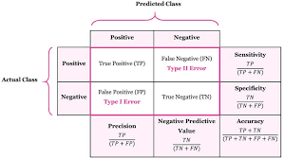
stats.stackexchange.com
terminology - What is the best way to remember the difference ...
Suggested filename: fig51-confusion-matrix-sens-spec.pdf
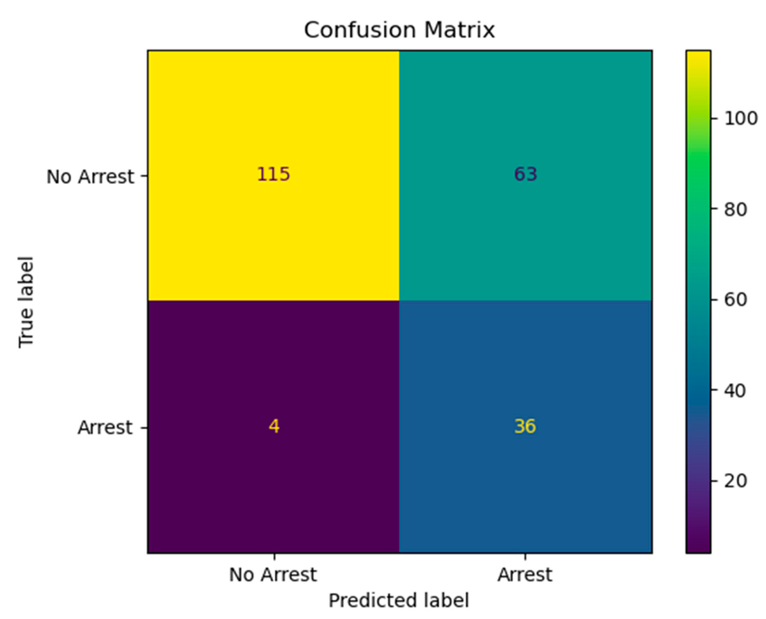
researchgate.net
Confusion matrix: the model had a sensitivity of 90% and a ...
Suggested filename: fig52-medical-confusion-matrix.pdf
Figure 53: BLEU and ROUGE score tables for LLM medical report generation evaluation (NLG metrics for draft quality.)
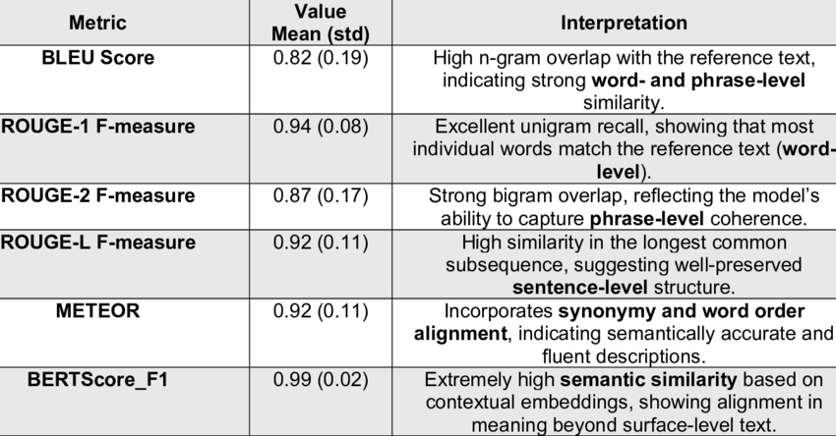
researchgate.net
Summary of text description evaluation metrics (BLEU, ROUGE ...
Suggested filename: fig53-bleu-rouge-table.pdf
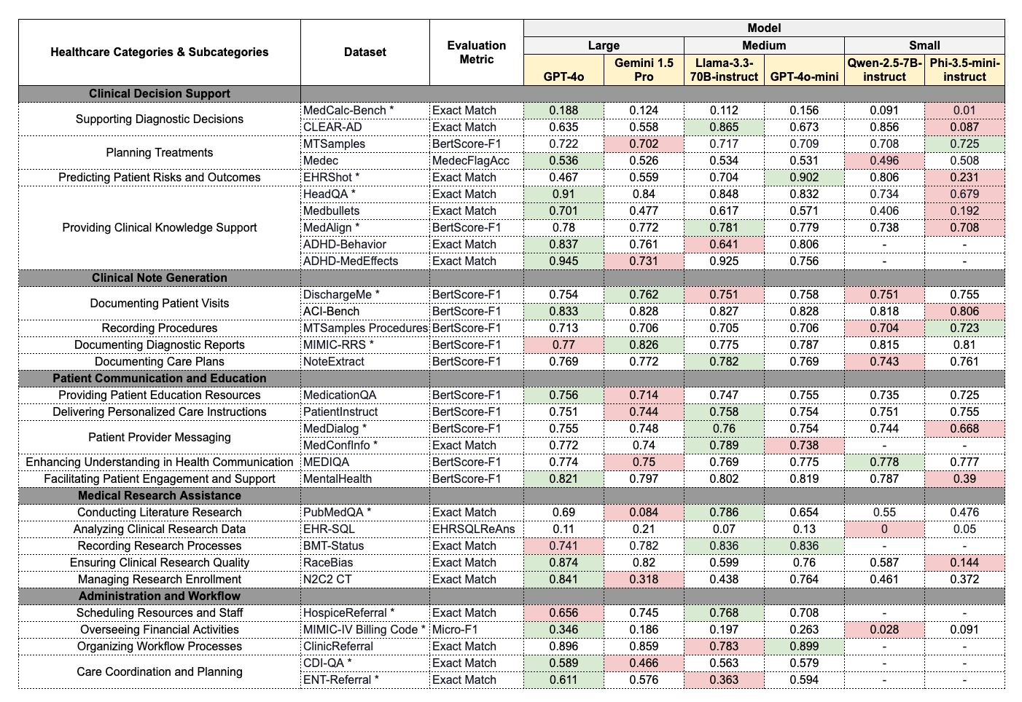
hai.stanford.edu
Holistic Evaluation of Large Language Models for Medical ...
Suggested filename: fig54-llm-medical-metrics.pdf
Figure 55: Time comparison charts for manual vs AI-assisted radiology reporting (Simulated workflow efficiency gains.)
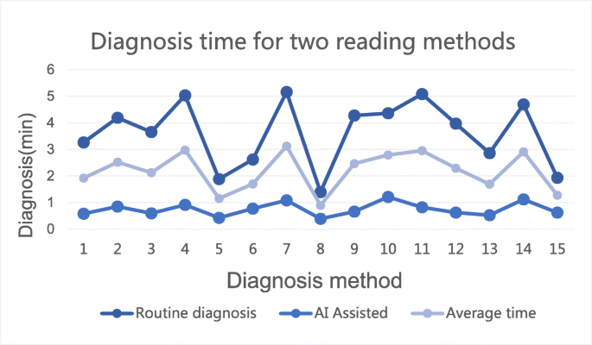
link.springer.com
RETRACTED ARTICLE: The value of artificial intelligence and ...
Suggested filename: fig55-ai-reporting-time-comparison.pdf
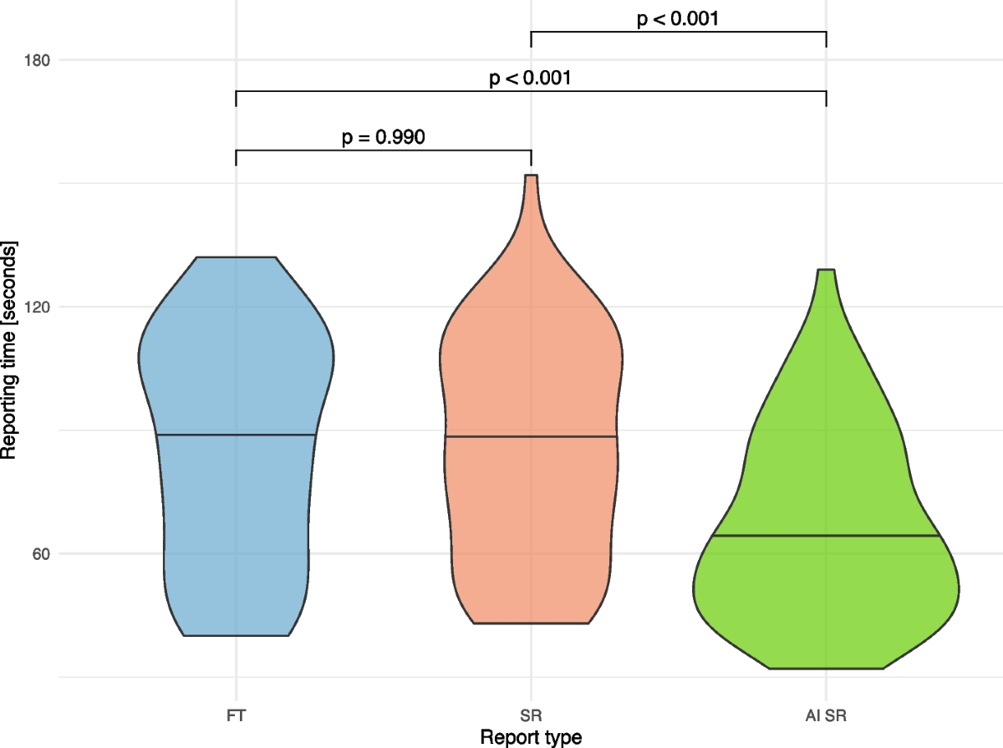
link.springer.com
A novel reporting workflow for automated integration of artificial ...
Suggested filename: fig56-radiology-workflow-time-chart.pdf
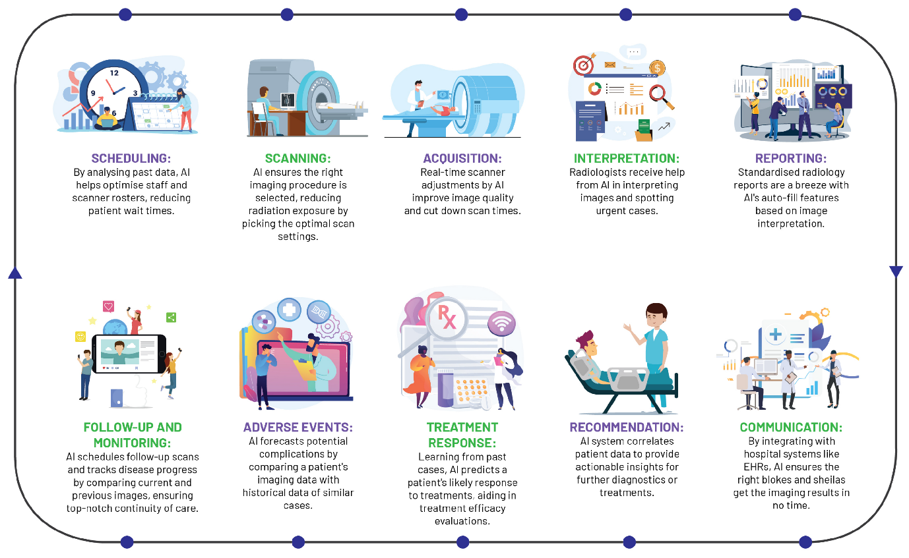
mdpi.com
Redefining Radiology: A Review of Artificial Intelligence ...
Suggested filename: fig57-ai-efficiency-bar-chart.pdf
Figure 58: Python logging and error handling examples (Structured logs for failures.)
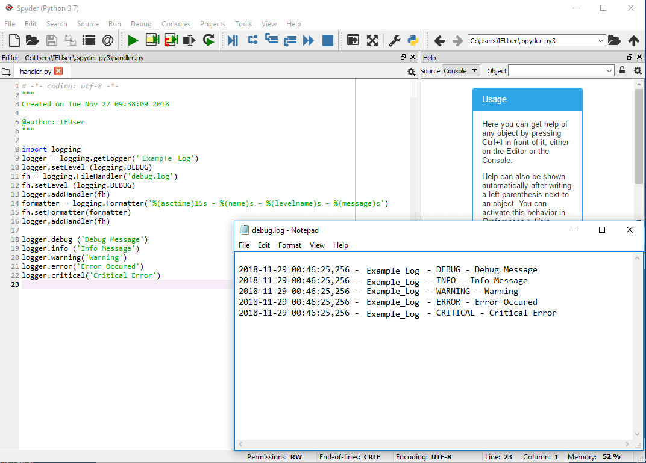
ionos.com
The Python logging module: How logging to file works - IONOS
Suggested filename: fig58-python-error-log.pdf
Evidence Artefacts for Repository
- /tests/: test_anonymizer.py, test_vit_inference.py, test_report_generator.py, test_pipeline_integration.py.
- Results: test_report.html (pytest-html output), coverage reports.
- Validation docs: Tables of metrics (CSV/Markdown), timed simulation logs.
- Logs: error_log_sample.txt (anonymised entries).
These artefacts provide verifiable evidence of robust development, performance, and error resilience, supporting claims of workflow improvement in pilot simulations.

